Lesson Title/Focus | Sketchbook- Mono print | Date | 03/31-32/2015
Subject/Grade Level | Art 10, 20, 30 | Time Duration | Blocks A,B,C  90 minutes
Unit | Printmaking | Teacher | Angela McPeake

OUTCOMES FROM ALBERTA PROGRAM OF STUDIES
General Learning Outcomes: | Art 10  Record: Combine Description, Expression and Cognition in the drawing process.  Art 20  Record: Draw for confidence and consolidation of head-to-hand skills.  Encounters: Transformations through time: Investigate the impact of technology on the intentions and productions of the artist.  Art 30  Investigate: Develop and refine drawing skills and styles.
Specific Learning Outcomes: | Art 10  Concept A: Subject matter and expressive intention can be depicted with a variety of notational marks.  Concept B: The expressive content of drawings is affected by the drawing media selected.  Art 20  Concept C: Combining mental images and representational images in drawing may provide a challenge to an individual’s drawing skills.  Concept A: The adoption of a new medium will effect change in an artist’s work.  Art 30  Concept A: A repertoire of drawing techniques is needed to express visual ideas.  Concept B: Explorations of a technical or creative nature may lead individuals into highly personalized work sessions.
LEARNING OBJECTIVES
Students will:
Create 3 mono prints:
- Their name- looking at typography in printmaking. Symbolism/representation of text styles.
- A landscape which explores texture, line, shape, positive/ negative space.
- Personal selection which investigates drawing expression.

ASSESSMENTS
Essential Questions: |  |  | - How does using a specific medium affect personal expression in an artwork?
Key Questions: |  |  | - What are the qualities seen in mono-printing techniques?  - How does mono-printing differ compared to other forms of printmaking?  - What considerations do you need make in creating a mono-print drawing compared to a graphite drawing?
Products/Performances: |  |  | - 3 mono prints
LEARNING RESOURCES CONSULTED |  |  |  | MATERIALS AND EQUIPMENT
- Alberta Art Curriculum: Elementary Teacher Resource 1985  - http://www.monoprints.com/history.php?PHPSESSID=787ea8eb30503093980f9d647feb644e  - https://inspirationparachute.files.wordpress.com/2011/04/bill-jacklin.jpg  - http://www.ianhopton.com/Life_Monotypes/art/Top-right.jpg  - http://skpgfinearts.com/Monoprint.html  - http://4.bp.blogspot.com/_viXydqJJKj0/TETE7gu7FsI/AAAAAAAAAB4/AwSMNN2XxsA/s1600/DSC00625.JPG  - https://www.flickr.com/photos/janebeharrell/9325458921/  - http://4.bp.blogspot.com/_Jn64sGT3HXM/TDiLUufTq5I/AAAAAAAAFzg/6e6cZKuaOi8/s1600/birdFlower.jpg |  |  |  | - Plexi-glass  - Brayer  - Barren  - Water-based print ink  - Paper assortment  - Matt board
PROCEDURE
Prior to lesson |  | Have materials ready for students to use. Exemplars made. PowerPoint ready.
Introduction |  |  |  |  | Time
Attention Grabber |  | Mono print examples on the smart board
Assessment of Prior Knowledge |  | Formative:  *Hands-up  “Who has done mono-printing before?”  “What are some of the qualities of mono-printing?”
Advance Organizer/Agenda |  | - Block A: Announcements, class registration  - Mono-print Artists  - Mono-print demo on typography  - Mono-print demo on landscape/ textured object  - Mono-print of choice- work period  - Block D: Lock down practice bell. |  |  | 90 mins
Vocabulary |  | - Brayer  - Barren  - Mono-print  - Additive method  - Subtractive method  - Elements of art
Artists of Influence |  | - Edgar Degas  - Camille Pissarro
Body |  |  |  |  | Time
Learning Activity #1 |  | As a whole group:  Formative assessment:  “Who has done mono-printing before?”  “What are the qualities of this medium?”  *Hands-up  PowerPoint:  What is Mono-printing? What is a mono-type?  Applying ink with a brayer onto a plexi-glass board. Using tools to add or take away ink, using techniques which cross between drawing and painting. Transfer this ink image to a piece of paper by laying the paper on top of the plexi-glass and rubbing the back of the paper with a baren.  -Significance of mono-type is that it only creates one single print. Whereas a mono-print uses similar content matter which is manipulated between prints.  -a variety of tools can be used to add and subtract ink in mono-printing. We will be using pieces of matt board as our tools. For the final mono-print students can find different tools to experiment with.  *Show images in powerpoint as examples of mono-prints.  Demo 1: Typography in mono-printing  -consider different texts as symbolic or representational. Examples: comic text, metal music text, certain band text (RUN DMC), horror style, etc.  -ask students if they can think of any representational text.  -consider that all text needs to be done backwards in printmaking.  *reference students creating lino-cuts.  -students can reverse text by using the light table to tracing the backside of a sheet with text.  In this first task students will be asked to create a mono-print of their name by selecting a certain style of text.  -demo this process and how to use the brayer, by rolling ink onto the plexi-glass, and removing the ink using a piece of matt board to create reversed text of your name.  *Students will have 20 minutes to do this task.  *Have students do a gallery walk around the classroom to look at other students artwork.  -“What qualities did you notice when using this medium? What were the challenges?” |  |  | 15 mins  20 mins
Teacher Notes: Assessments/ Differentiation |  | Blooms Taxonomy Level:  Type 1: Understanding  -What is mono-printing?  -what qualities are seen in mono-printing?  -Tools, materials.  Formative Assessment:  *Hands up  “Who has done mono-printing before?“  -answering any questions
Learning Activity #2 |  | Demo 2: Mono-print illustrating texture in a landscape  -Students will create a mono-print which illustrates different textures in their object using different additive and subtractive techniques. This is a time to experiment and see the different things this medium can do for expression in the artwork.  -Demo making a landscape. This is good subject matter because it allows for application of many different techniques. Students can explore the idea of texture, line, shape, tone, and positive/negative space.  *Students will have 20 minutes to create this mono-print.  *have students do a gallery walk around the classroom to see what their peers have created.  *”What did you notice is working well in some of the mono-prints you have seen?”  TASK 3: mono-print of choice.  -Students can apply their knowledge to create a mono-print of their choice.  CALL CLEAN UP 10 MINUTES PRIOR TO END OF CLASS. |  |  | 20 mins  20 mins  10 mins
Teacher Notes: Assessments/ Differentiation |  | Blooms Taxonomy Level:  Type 1: Understanding  -Tools, materials  Type 2: Applying and Analyzing  -understanding which tools and techniques to use to create desired effects.  Type 3: Creating and Evaluating  -Making mono-prints  *Formative assessment through discussion and answering questions  *Circulate classroom and provide students with verbal feedback and assistance through the task.
Closure |  |  |  |  | Time
Consolidation of Learning: |  |  | “ Some of the expressive qualities mono-printing offers are texture, line, and a painting like appearance. A challenge in mono-printing is that your cannot edit the print and there is only one print as a result.”
Feedback From Students: |  |  | What did you like about using this medium?
Feedback To Students |  |  | You will have the opportunity to finish your mono-prints tomorrow. Tomorrow students will be working on continuing projects.

Sponge Activity/Activities | Finish continuing projects:  Art 10: finishing clay, starting stencils  Art 20: finishing stained glass, continuing on papermaking and lino-cuts.  Art 30: individual projects

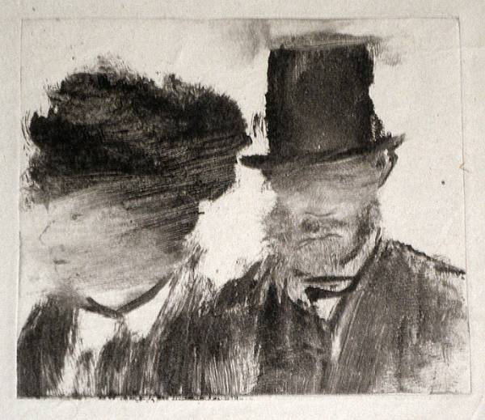
Edgar Degas
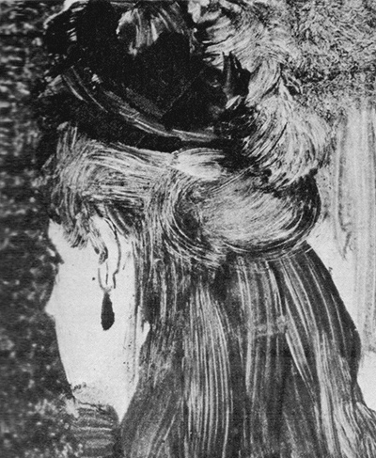
Degas, The Jet Earring; monotype; 1876-77
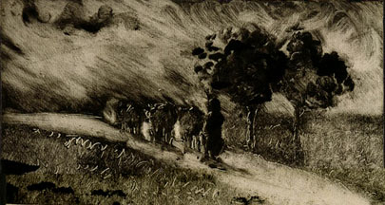
Camille Pissarro Vacherie le soir, c. 1890 Monotype in warm black on wove paper sheet
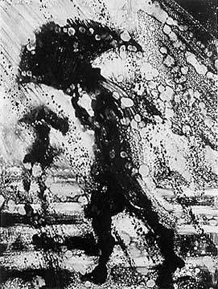
https://inspirationparachute.files.wordpress.com/2011/04/bill-jacklin.jpg
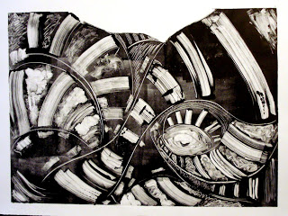
Andrew White, Crossing Paths, Monotype
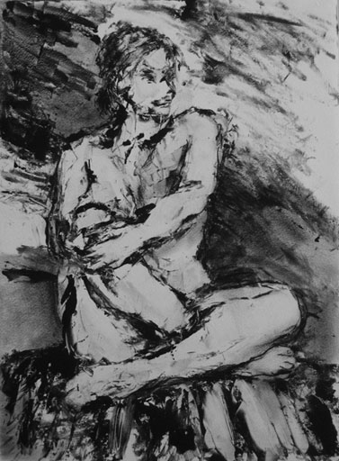
Ian Hopton, Life monotype
http://www.ianhopton.com/Life_Monotypes/art/Top-right.jpg
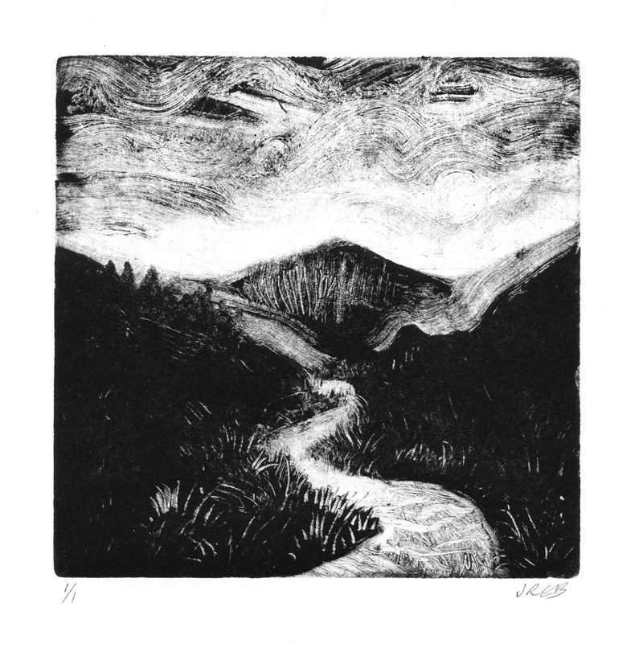
https://www.flickr.com/photos/janebeharrell/9325458921/
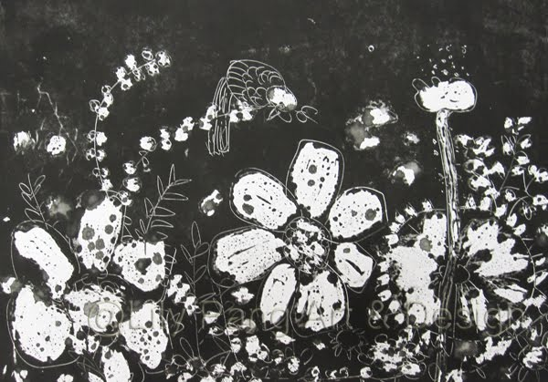
http://4.bp.blogspot.com/_Jn64sGT3HXM/TDiLUufTq5I/AAAAAAAAFzg/6e6cZKuaOi8/s1600/birdFlower.jpg

