Lesson Title/Focus | Sketchbook: Scratch Art | Date | 03/26/2015
Subject/Grade Level | Art 10, 20, 30 | Time Duration | Blocks A,B,D  90 minutes
Unit | Sketchbook tasks | Teacher | Angela McPeake

OUTCOMES FROM ALBERTA PROGRAM OF STUDIES
General Learning Outcomes: | Art 10:  Record: Combine description, expression and cognition in the drawing process.  Investigate: Develop and refine drawing skills and styles.  Art 20:  Compositions: Use non-traditional approaches to create compositions in both two and three dimensions.  Encounters: Investigate the impact of technology on the intentions and productions of the artist.  Art 30:  Investigate: Develop and refine drawing skills and styles.  Compositions: Use personal experiences as sources for image making.
Specific Learning Outcomes: | Art 10:  Concept B: The expressive content of drawings is affected by the drawing media selected.  Concept B: Tactile qualities of surfaces can be rendered through controlled use of line.  Art 20:  Concept A: The use of non-traditional media affects the development of a two- or three- dimensional object.  Concept A: The adoption of a new medium will effect change in an artist’s work.  Art 30:  Concept B: Explorations of a technical or creative nature may lead individuals into highly personalized work sessions.  Concept B: Planned and spontaneous methods of working are ways of developing visual images.
LEARNING OBJECTIVES
Students will:
- Create a drawing on a scratchboard using different scratch tools.
- Explore different elements of line, tone, value, shape, movement, texture and space in drawing.
ASSESSMENTS
Essential Questions: |  |  | - How does using a non-traditional art medium affect your art practice?
Key Questions: |  |  | - In using a non-traditional drawing medium such as scratchboard, how is it different then using graphite?  - What considerations do we need to make when drawing on a scratchboard?
Products/Performances: |  |  | - 1 scratchboard drawing
LEARNING RESOURCES CONSULTED |  |  |  | MATERIALS AND EQUIPMENT
- Alberta Art Curriculum: Elementary Teacher Resource 1985  - http://www.sallymaxwell.com/originals  - http://www.cathysheeter.com/scratchboard.html  - http://www.loridunnart.com/First-Bloom.html  - http://rainboworhidee.deviantart.com/art/Scratch-Art-Self-Portrait-369631565  - http://www.strangebeaver.com/2012/08/interesting-batman-scratch-art/  - http://www.deviantart.com/art/Landscape-356246435  - http://api.ning.com/files/xMNIRqxVc1KGCxSwUoFQsMJlylF0r20USQzmGJ5VcftXw9tHFdiK22tooIzcQBjTJUkq0FPj3uz2Q*1oZ6SHeg__/IMG_0608.JPG?width=431&height=600  - http://imgkid.com/black-and-white-scratch-art.shtml |  |  |  | - Scratchboard for each student  - Scratching tools  - Smart board  - Exemplars PowerPoint
PROCEDURE
Prior to lesson |  | Materials ready for students, smart board presentation ready
Introduction |  |  |  |  | Time
Attention Grabber |  | Scratchboard exemplars on the smart board
Assessment of Prior Knowledge |  | Formative:  *Hands-up  “Who has done scratchboard art before?”  “What did you like about using this drawing medium?”
Advance Organizer/Agenda |  | - Block A: Announcements  - Scratch art Artists  - Scratch art demo  - Work time |  |  | 90 Minutes
Vocabulary |  | - Line  - Tone and value  - Shape  - Space: foreground, middle ground, background  - Movement  - Texture  - Composition  - Scratch board
Artists of Influence |  | - Sally Maxwell  - Cathy Sheeter
Body |  |  |  |  | Time
Learning Activity #1 |  | As a whole group:  Formative assessment  “Who has done scratch board before?”  “What is a limitation of this medium?”  How does using scratchboard differ from using graphite?”  *hands-up  PowerPoint:  What is a scratch board?  -Three layers: masonite board with a layer of white plaster, and the top layer is black India ink.  -Scratching tools are used to remove the black India ink and expose the white plaster. The India ink is scratched off in a series of dots and scratches.  -Variations of tone and value are created through the density of dots/scratches (removed India ink)  -Colored inks can be added to the exposed white clay after the India ink is scratched away  *The scratch board which we will be using is made of white paper with the black ink over-layer which can be easily removed.  Show examples of scratchboard artists work on the PowerPoint.  -identify how tone and value is created with the use of lines and texture.  -identify that scratchboard can be done simply or become very complex.  Demo:  At the small demo table illustrate how to use the scratchboard:  - Show the different tools which can be used for scratching and their effects.  - Note that pushing too hard may rip the paper.  - Demonstrate different scratching techniques: cross hatching, dots, line work.  - Remove little bits at a time so you don’t make mistakes as easily.  - You need to be adaptable when using this medium. You cannot reverse any of the scratches you make so you need to make changes in your plans if you make a mistake.  - You can create varying tones according to how much black ink you remove.  Safety:  - The tools are deceivingly sharp so be mindful when using them.  *the scratchboard is a standard paper size. You can use the paper cutter to size your scratchboard accordingly. Think about sharing the scratchboard with a partner. |  |  | 15-20 mins
Teacher Notes: Assessments/ Differentiation |  | Blooms Taxonomy Level:  Type 1: Understanding  -What is scratch board art?  -Tools, materials, and safety.  Formative Assessment:  *Hands up  “Who has done scratch art before? “  -answering any questions
Learning Activity #2 |  | Work time:  - In this work time students are expected to be working on their scratchboards.  - When finished students can work on other continuing projects.  - Students can make more than one scratch board drawing if they like.  CALL CLEAN UP 10 MINUTES PRIOR TO END OF CLASS |  |  | 60 mins  10 mins
Teacher Notes: Assessments/ Differentiation |  | Blooms Taxonomy Level:  Type 1: Understanding  -Tools, safety, and materials  Type 2: Applying and Analyzing  -understanding which tools and techniques to use to create desired effects.  Type 3: Creating and Evaluating  -Making a scratch board drawing  *Formative assessment through discussion and answering questions  *Circulate classroom and provide students with verbal feedback and assistance through the task.
Closure |  |  |  |  | Time
Consolidation of Learning: |  |  | “Everyone should be finishing up their scratchboards, tomorrow will be a work period to finish the scratchboards if you do not finish. In this work period you will also have the time to work on your other assignments:  Art 10: finishing clay, starting stencils  Art 20: finishing stained glass, continuing on papermaking and lino-cuts.  Art 30: continuing ongoing projects  We would like to hand in and evaluate the first assignments tomorrow”
Feedback From Students: |  |  | Who is not done their scratchboard and needs more time to work on it?
Feedback To Students |  |  | If you’re interested doing more scratch board we can look into making our own scratchboards.

Sponge Activity/Activities | Finish continuing projects:  Art 10: finishing clay, starting stencils  Art 20: finishing stained glass, continuing on papermaking and lino-cuts.  Art 30: individual projects

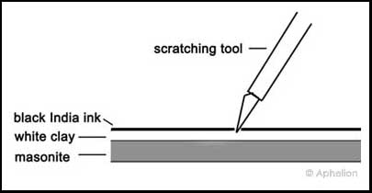
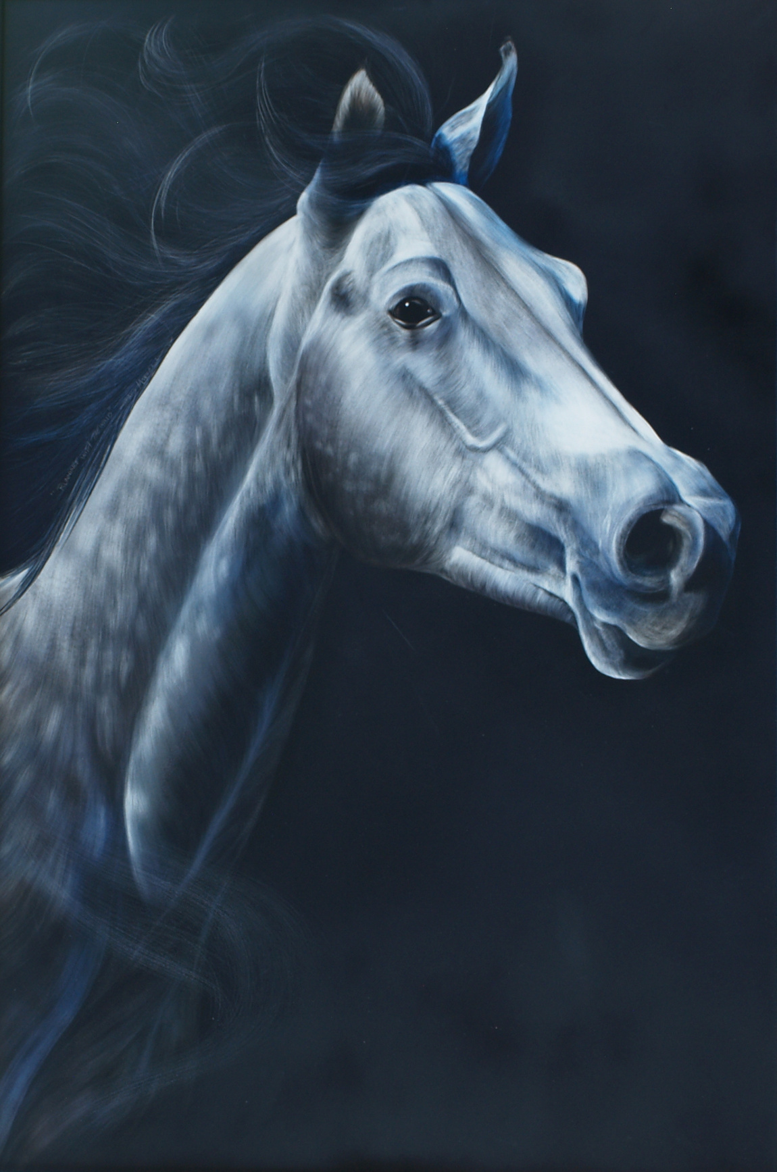
Sally Maxwell
Running with the Wind
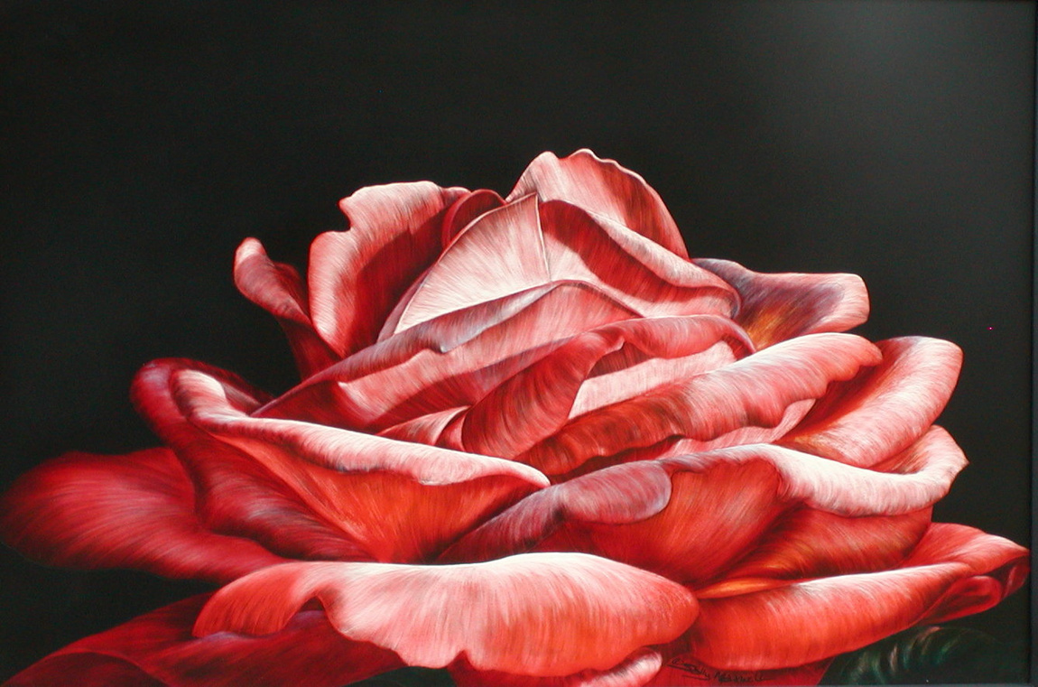
Sally Maxwell
Coral Rose
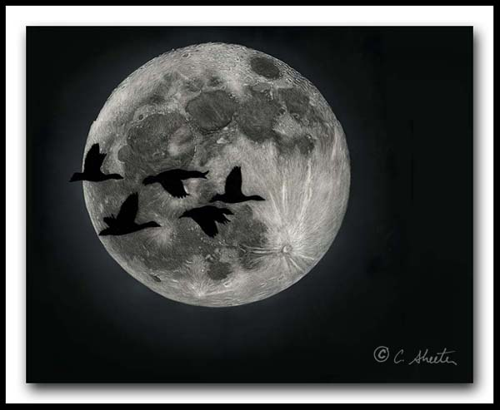
Cathy Sheeter
Bosque Moonrise
(snow geese)
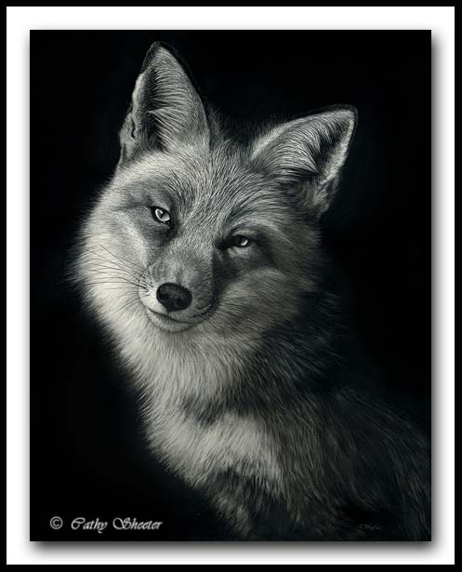
Cathy Sheeter
Foxy Lady
(Red Fox)
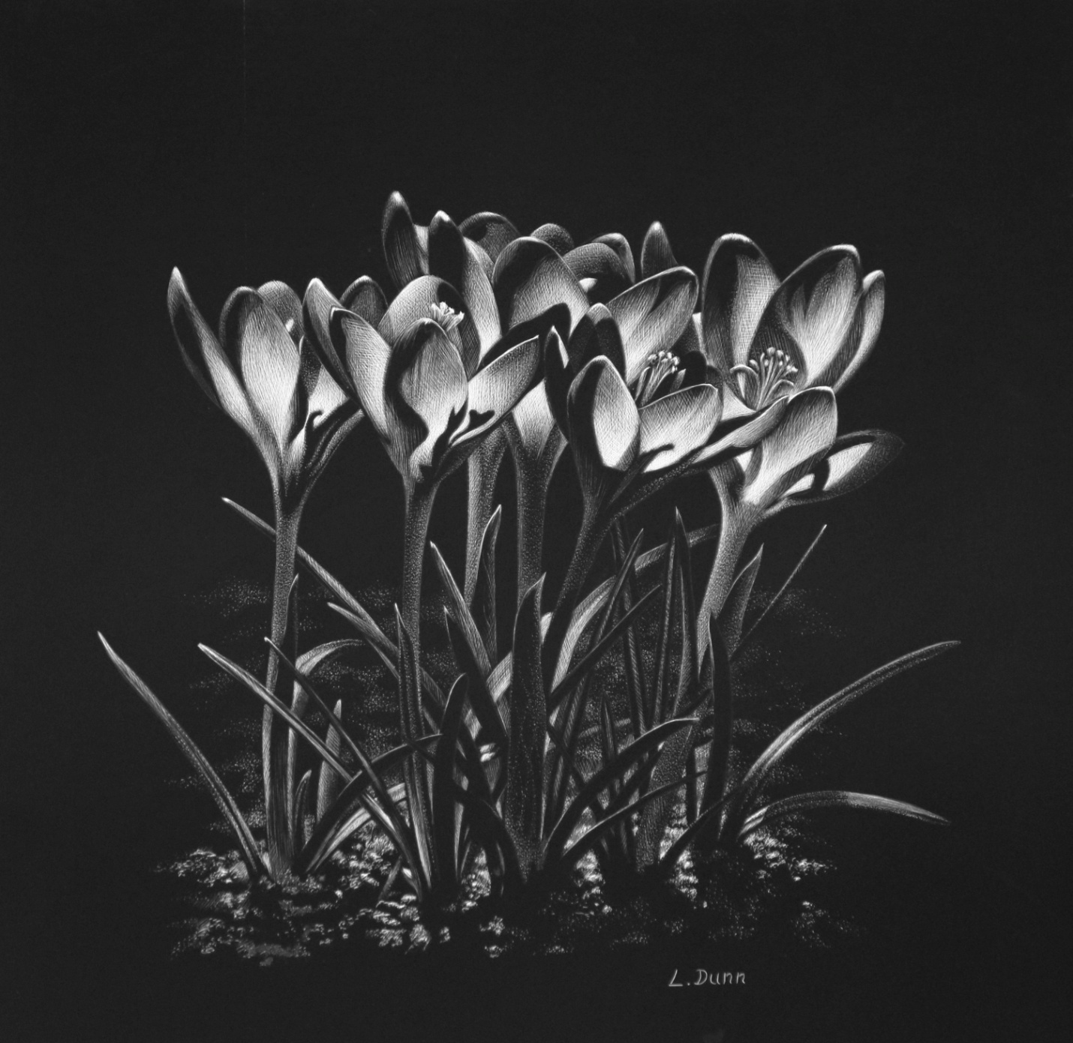
Lori Dunn
First Bloom
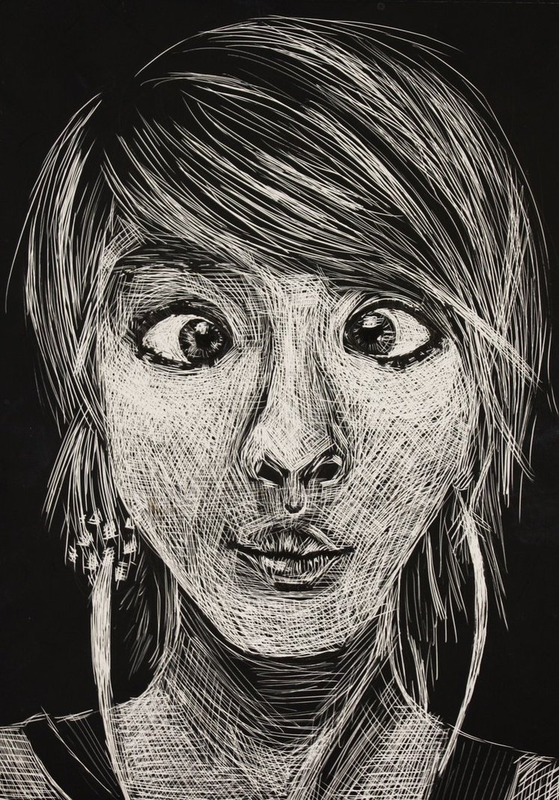
http://rainboworhidee.deviantart.com/art/Scratch-Art-Self-Portrait-369631565
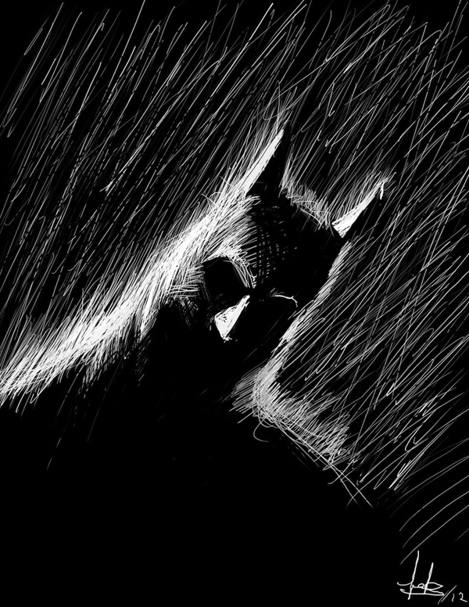
Eduardo Cortes Trujillo
‘Batman’
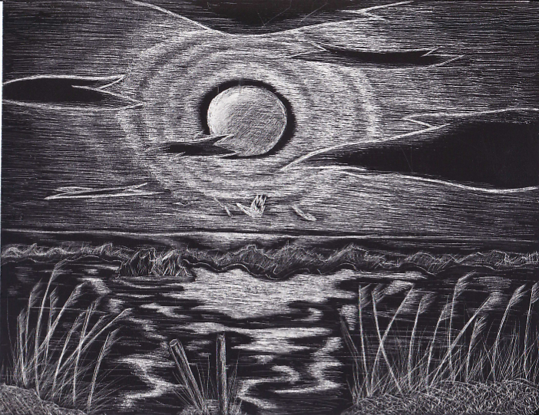
Artist unknown
Landscape
http://www.deviantart.com/art/Landscape-356246435
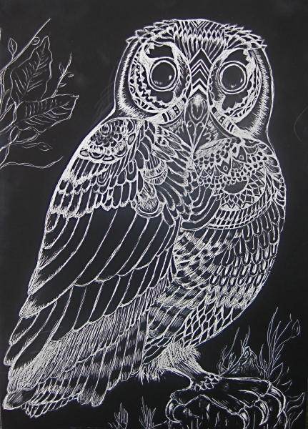
http://api.ning.com/files/xMNIRqxVc1KGCxSwUoFQsMJlylF0r20USQzmGJ5VcftXw9tHFdiK22tooIzcQBjTJUkq0FPj3uz2Q*1oZ6SHeg__/IMG_0608.JPG?width=431&height=600
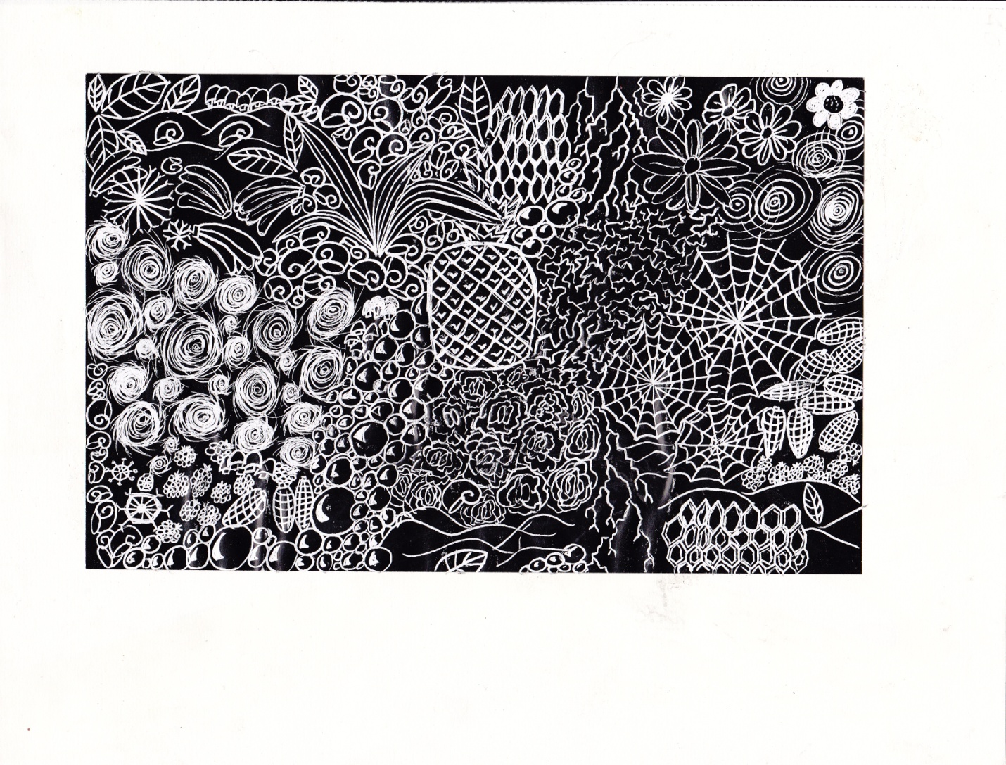
http://fc07.deviantart.net/fs71/f/2011/126/f/b/school_project___scratch_art_by_coreggio98-d3fqoyv.jpg
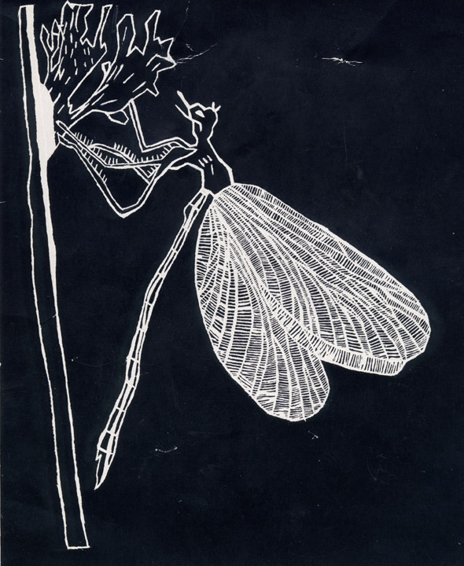
http://kozmicdreams.com/Teaching/Level%202/Scratchboard/Dragonfly%20Shane.jpg

